**Reply to Reviewer’s Comments (manuscript number RSI24-CF-HTPD2024-00833)**

We are grateful to the Reviewer for the thorough review of our manuscript and for the constructive comments. Specifically, the Reviewer asked valuable questions and pointed out many places where the manuscript can be improved. The following are our replies and revisions in response to the Reviewer’s comments.

**Reviewer #2**

**Comment 1**

I suggest that the manuscript is revised acknowledging that simple RMS with fixed nuisance parameters without heed of their uncertainties is not the current reference standard.

**Reply and Revision 1**

We thank the Reviewer for the suggestion that the nuisance parameter would have uncertainties. We have updated the least squares fitting method to the LSN method, which considers the uncertainty of nuisance parameters, and made the following revisions:

*“*

Fig. 4. The calculation results of least squares fitting with fixed nuisance parameters

*Table 1 provides the expected value and uncertainty for all parameters. Using the noisy scattering spectrum in Fig. 3 as an input, and the spectral decomposition is based on least squares fitting with fixed nuisance parameters (LSN)9. To qualitatively illustrate the limitations of LSN, it is assumed that the nuisance parameters, with the exception electron temperature, are at their true values. Subsequently, a set of ion temperatures is calculated by varying only the electron temperature and only the covariance of electrons, as depicted in Fig. 4. When the prior information regarding electron temperature deviates from its true value, the ion temperature calculated by LSN will also deviate from its true value. In reality, the situation is more complex, and the measured values of prior information for all nuisance parameters may diverge from their true values. Therefore, LSN cannot consistently yield accurate ion temperature estimates. Consequently, when only scattering spectra are available, we require a method that can provide relatively reliable ion temperatures to supplement the limitations of LSN.”*

**Comment 2**

It would be helpful if the authors would indicate whether all parameters are allowed to vary when computing the simulated spectra in the search for optimum or only the parameter of interest (the ion temperature). It would also be helpful to clarify what assumptions about the nuisance parameters are made in computing spectra. This could be done in contest of the statement in the manuscript that inference is made without reliance on other diagnostics.

**Reply and Revision 2**

We thank the Reviewer pointing out that the unclear statement regarding whether all parameter allowed to vary when spectral decomposition. We premise our analysis on the assumption that all parameters, including nuisance parameters, have their variation ranges (eg. the uncertainty of measured Te due to the measuring error). These parameter ranges do not need to be very precise, of course, more precise parameter ranges will make our results tend towards true values. During the process of the improved GA crossover and mutation, we endeavor to optimize these parameters within the predefined parameter space. We made the revisions in the penultima paragraph of section 5.

*“…The GA was executed with a maximum iteration count of 100 and a population size of 100.* *We premise our analysis on the assumption that all parameters, including nuisance parameters, are known to have their possible distribution ranges, as shown in Table 1. Within the framework of the improved GA, specifically during the processes of crossover and mutation, we endeavor to optimize these parameters within the predefined parameter space. Here we only provide the predicted results of ion temperature in Table 4. The maximum value calculated by GA with RMSE is 1.12 keV…”*

**Comment 3**

The noise added to the synthetic measured spectra (eq. 3) should specify for which spectral resolution it applies.

**Reply and Revision 3**

We thank the Reviewer pointing out the unclear aspects in eq. 3. We made the revisions in the first paragraph of section 3.

“…*where $S_{sim}\left(\overset{⃑}{k},ω\right)$ is the spectral density given by the forward model, ~~and~~ is a normal distribution with a mean of 0 and a variance of 0.01, and the frequency resolution of the scattering spectra is 1 MHz.*”

**Comment 4**

The sensitivity analysis shows little sensitivity to scattering angle, theta. This holds for back scattering with limited uncertainty in theta. The situation would be very different for forward scattering (small value of theta). Sensitivity to phi (presumably the angle between k_delta and B) is also small. That would be different if phi was in the range 85 degrees to 95 degrees. So, I suggest that the manuscript notes that this sensitivity analysis is specific to the chosen parameter ranges.

**Reply and Revision 4**

We thank the Reviewer pointing out the parameter range of sensitivity analysis is not clearly stated. We made the revisions in the third paragraph of section 4.

“*It should be noticed that the sensitivity analysis conducted above may tailored to the specific parameter ranges outlined in Table 1. When the CTS parameter ranges change, such as a forward scattering case with very small value of $θ$, the sensitivity relation will be different from the result shown in Fig. 5.*”

**Comment 5**

The reference list is lacking some bibliographic details. The reference give above seems to be a relevant reference point to this manuscript.

**Reply and Revision 5**

We thank the Reviewer pointing out the reference lacks some information. Additional reference information has been added and the lacking information has also been supplemented.

Such as:

“1R. Behn et al., Phys. Rev. Lett. 62, 24 (1989).

2H. Bindslev et al., Phys. Rev. Lett. **97,** 205005 (2006).

3M. Stejner et al., Rev. Sci. Instrum. **81,** 10D515 (2010).

4D. Moseev et al., Plasma Phys. Control. Fusion **53,** 105004 (2011).

5M. Stejner et al., Plasma Phys. Control. Fusion **55,** 085002 (2013).

6S. K. Nielsen et al., Plasma Phys. Control. Fusion **55,** 115003 (2013).

7M. Nishiura et al., Nucl. Fusion **54,** 023006 (2014).

8J. Svensson et al., 2007 IEEE International Symposium on Intelligent Signal Processing.

9H. Bindslev, Rev. Sci. Instrum. **70,** 1 (1999).

10M. Escalona et al., Scientific Reports **13,** 13002 (2023).

11S. Katoch et al., Multimedia Tools and Applications **80,** (2021).

12A. Lambora et al., 2019 International Conference on Machine Learning, Big Data, Cloud and Parallel Computing (Com-IT-Con).

13Y. B. Lu et al., Appl. Artif. Intell. **38,** 1 (2024).

14X. Li et al., Int. J. Production Economics **174,** (2016).

15K. Wang et al., Applied Soft Computing **107,** 107404 (2021).

16Xingui He et al., Journal of Software **12,** 7 (2001).

17Q. Chen et al., Mechanical Systems and Signal Processing **21,** (2007).

18T. P. Hughes et al., Nuclear Fusion **28**, 8 (1988).

19T. P. Hughes et al., J. Plasma Physics **42**, 2 (1989).

20I. M. Sobol et al., Reliability Engineering and System Safety **92**, (2007).

21S. Marino et al., Journal of Theoretical Biology **254**, 1 (2008).

22T. Homma et al., Reliability Engineering and System Safety **52**, 1 (1996).

23A. Saltelli, Risk Analysis **22,** 10-11 (2002).

24K. I. Gasior et al., Bull. Math. Biol. **86,** (2024).

25G. Zou et al., 2012 8th International Conference on Natural Computation.

26S. Jadon, 2020 IEEE Conference on Computational Intelligence in Bioinformatics and Computational Biology.

27M. Srinivas et al., IEEE Transaction Son Systems, Man and Cybernetics **24**, 4 (1994).”

Thanks a lot for the professional and constructive suggestions of the Reviewer. We hope these responses address your concerns adequately.

**Reviewer #3**

**Comment 1**

"The collective Thomson scattering (CTS)1-4 is an important diagnostic technique that injects highly monochromatic and high-power probe beams into plasma and measures the scattering spectra of injected beams." I wonder about your choice of references. I agree that the work of Behn et al is the first CTS measurement (using actually lasers, not microwaves). The references to the JET results of Bindslev et al (1999) is really not the best example of the fast ion CTS measurements and it is probably a single case for JET, since the diagnostic there was cancelled and never worked again. There are high-quality CTS results from TEXTOR, ASDEX Upgrade, TEXTOR, LHD, and W7-X. The results from TEXTOR which you cite are about observation of a very specific phenomena, IBW and IC waves in the scattering spectra and is by no means a standard operation regime. Why would not you search one of many actually relevant papers on CTS in TEXTOR? The paper by Abramovic is solely about modelling and actually Bayesian inference and not about the diagnostic use at all. It may be relevant to your paper but not in this context.

**Reply and Revision 1**

We thank the Reviewer pointing out the insufficient citation of references. Your suggestion is very helpful for us and for the improvement of this manuscript. We have removed previously irrelevant or unimportant references and added some more valuable ones. Here are some updated references.

We have mainly updated the references for CTS experiments:

*“*1R. Behn et al., Phys. Rev. Lett. 62, 24 (1989).

2H. Bindslev et al., Phys. Rev. Lett. **97,** 205005 (2006).

3M. Stejner et al., Rev. Sci. Instrum. **81,** 10D515 (2010).

4D. Moseev et al., Plasma Phys. Control. Fusion **53,** 105004 (2011).

5M. Stejner et al., Plasma Phys. Control. Fusion **55,** 085002 (2013).

6S. K. Nielsen et al., Plasma Phys. Control. Fusion **55,** 115003 (2013).

7M. Nishiura et al., Nucl. Fusion **54,** 023006 (2014).*”*

**Comment 2**

I don't really understand what you mean by "By applying GA to spectral decomposition, we can obtain relatively accurate ion temperatures without relying on the measurement of other diagnostic systems." Maybe GAs are very good but there is no magic: many plasma parameters have similar influence on the spectral shape and without you having good prior information, you won't be able to infer the values. I can give a typical example: lowered Te and Ti have similar effect on the spectrum as an increased impurity content. Without having prior on data on ne and Te profiles you won't often be able to address the question of refraction of the probe and receiver beams, therefore having little idea about your scattering angle, angle to the magnetic field, the magnetic field induction. This list can be continued. Your statement is very controversial, please specify what you need.

**Reply and Revision 2**

We thank the Reviewer pointing out the potential issues when using GA, as well as the unclear expressions. We realize that the nuisance parameters measured by other diagnostic systems can carry significant measurement errors. In this context, we are discovered that calculated results of GA remain satisfactory. Specifically, when faced with situations where certain diagnostic data is absent or clearly inaccurate, GA have become an attractive spectral decomposition method due to their powerful global search ability. Based on your revision suggestion, we have made the relevant description clearer:

*“Genetic algorithm (GA) is the most widely employed optimization algorithm for multi-parameter fitting, originating from natural genetic mechanisms and biological evolution theory. GA has good global optimization capabilities and do not require precise prior information ~~knowledge~~. In addition, GA can also be combined with other algorithms to form hybrid optimization algorithms with better performance.”*

**Comment 3**

I could not figure out from your manuscript whether you develop your algorithms for a generic diagnostic or having anything specific in mind. Specifically, I refer to table 1 "The design objective of the CTS diagnostic system." Where do you design it, for which machine? What does it suppose to measure? What are your target values of SNR? I am specifically puzzled about the time resolution of 5 us. I never heard of any mm-wave based CTS being able to achieve anything beyond 1 ms. Again, what are you targeting at measuring? This should also affect the achievable time resolution drastically.

**Reply and Revision 3**

We thank the Reviewer pointing out the design issues of the CTS diagnostic system. ~~These questions are very important, we will answer them one by one for you.~~

1. ~~“I could not figure out from your manuscript whether you develop your algorithms for a generic diagnostic or having anything specific in mind.”~~

~~Our goal is to develop a universal algorithm for spectral decomposition. The measured parameters of CTS are estimated on EAST Tokamak, as an application example of this new algorithm.~~

1. ~~“Where do you design it, for which machine?”~~

~~We designed the CTS diagnostic system based on EAST. At present, the relevant design work has not been published yet, and we look forward to your valuable suggestions after the publication of the design work paper.~~

1. ~~“What does it suppose to measure?”~~

~~We expect this system to provide us with a more accurate temperature of the bulk ions in the core.~~

1. ~~“What are your target values of SNR?”~~

~~In most frequency bands where the main ion plays an important role, the target signal-to-noise ratio of this system is around 10.~~

~~The above answers may not completely solve your confusion, but they are beyond the scope of this study, we look forward to your valuable suggestions when our design work is published. This part is indeed not suitable in this paper, so we have made the following revisions:~~

~~We have removed the paragraph describing the design objectives of the CTS diagnostic system and added a brief description of the system in the first paragraph of the introduction.~~

*~~“…Important plasma parameters such as the bulk ion temperature, fast ion velocity distribution function, and ion composition can be obtained from the scattering spectra by spectral decomposition. The measured parameters of CTS diagnostic system are estimated on EAST Tokamak. And the goal of this system is to measure the temperature of the core main ion. Further technical details about the CTS diagnostic system are beyond the scope of this study and not included.~~*

*~~Bayesian estimation and least squares fitting have been applied to this spectra decomposition process.…”~~*

Our goal is to develop a universal spectral decomposition algorithm. And We have designed a CTS diagnostic system based on KTX, which is a medium size reversed field pinch device, aimed at measuring the temperature of the bulk ions. The system is planned to use a gyrotron as the probe source, with a pulse power of 1MW and a pulse duration of 5us. The KTX operates at a very low magnetic induction intensity (the maximum toroidal field $B_{T} = 0.35 T$, and the corresponding electron cyclotron frequency $f_{ce}=9.79 GHz$). Since the probe frequency is much higher than the electron cyclotron frequency, the background noise level is very low. Furthermore, to further enhance the signal-to-noise ratio, we have also carefully designed the electronic system for the receiving modules. Currently, relevant work is still being organized, and we look forward to your valuable suggestions when our design work is published. However, this part is beyond the scope of this study and indeed not suitable for inclusion in this paper, so we have omitted the paragraph describing the design objectives of the CTS diagnostic system.

**Comment 4**

The noise which you applied to the synthetic spectra is very optimistic. How does the quality of inference change with increased noise?

**Reply and Revision 4**

We thank the Reviewer pointing out the problem of insufficient examples. We made the revisions in the last paragraph of section 5.

*“*

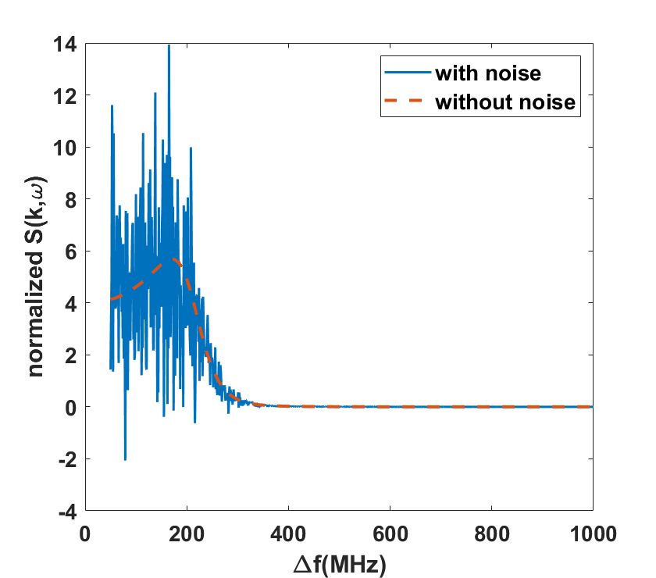

*Fig. 6. The spectral density $S\left(\overset{⃑}{k},f\right)$ with and without colored noise normalized to their mean value versus frequency shift. The plasma parameters are the same as in those used in Fig. 3.*

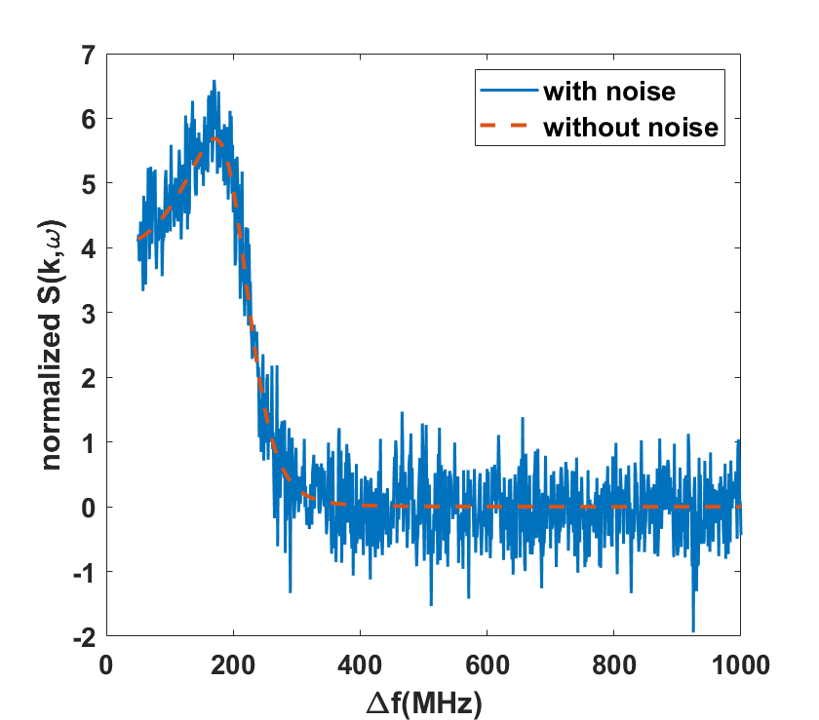

*Fig. 7. The spectral density $S\left(\overset{⃑}{k},f\right)$ with and without white noise normalized to their mean value versus frequency shift. The plasma parameters are the same as in those used in Fig. 3.*

|  |  |  |  |
| --- | --- | --- | --- |
| *Noise* | *Maximum*  *(keV)* | *Minimum*  *(keV)* | *Average*  *(keV)* |
| *Colored* | *1.136* | *1.011* | *1.082* |
| *White* | *1.068* | *0.971* | *1.027* |

*Table 5. The calculation results of ion temperature using GA with MFSS for two different noises.*

*In order to test the robustness of the improved GA under different noises, we have added two additional cases. Case I is to increase the colored noise in formula (3) to 50% as shown in Fig 6, and Case II is to add white noise equivalent to 50% of the average of the spectral as shown in Fig 7. The calculation results for these two cases are shown in Table 5, the maximum value calculated is 1.136 keV and the average value is 1.082 keV for colored noise, the maximum value calculated is 1.066 keV and the average value is 1.036 keV for white noise. Even under such adverse signal conditions, the improved GA can still obtain relatively satisfactory results, proving that it indeed has a certain level of robustness. Furthermore, the improved GA seems to exhibit enhanced robustness when confronted with white noise perturbations.* *A more comprehensive dataset is imperative for rigorous validation and analysis.”*

**Comment 5**

How is your GA better than other methods used in Bayesian analysis? Some methods like simulated annealing allow convergence in the global minimum, which seems to be challenging for the GAs.

**Reply and Revision 5**

We thank the Reviewer pointing out the challenges faced by our improved genetic algorithm. These questions are of great practical significance.

1. “How is your GA better than other methods used in Bayesian analysis?”

Genetic algorithm can explore multiple potential solutions simultaneously in the solution space by simulating natural selection and genetic processes, thereby increasing the probability of finding the global optimal solution. It is particularly suitable for solving optimization problems with multiple local optima or multimodality. And we improved the accuracy of the target parameters by constructing the fitness function of GA. Although Bayesian estimation also has certain global search capabilities, genetic algorithms perform more prominently in global search. Secondly, Bayesian estimation relies on prior knowledge during the updating process. If prior knowledge is inaccurate, the performance of Bayesian estimation may be affected.

1. “Some methods like simulated annealing allow convergence in the global minimum, which seems to be challenging for the GAs.”

Indeed, the GAs are now facing challenges from these algorithms. However, the GAs still play an important role in many fields, mainly because 1) the GAs deal with multiple individuals in a population, so they are naturally suitable for parallel processing. In the context of modern computer hardware development, this feature enables genetic algorithms to effectively utilize multi-core processors to accelerate computation; 2) the GAs has strong scalability and flexibility, making them easy to combine with other algorithms or technologies to improve performance. For example, the GAs can be combined with simulated annealing algorithms, Tabu search algorithms, etc. to form hybrid optimization algorithms1, 2.

Reference:

1Xinyu Li, et al., Int. J. Production Economics, 174, 93(2016).

2Kaipu Wang, et al., Applied Soft Computing, 107, 107404(2021).

And we have made the following revisions in the third paragraph of the introduction:

*“Genetic algorithm (GA) is the most widely employed optimization algorithm for multi-parameter fitting, originating from natural genetic mechanisms and biological evolution theory.* *GA has good global optimization capabilities and do not require precise prior knowledge. In addition, GA can also be combined with other algorithms to form hybrid optimization algorithms with better performance.*

*The fitness function of GA is a critical component, which strongly influences the optimized direction and the optimization performance.…”*

Thanks a lot for the professional and constructive suggestions of the Reviewer. We hope these responses address your concerns adequately.

In summary, we have adopted all the suggestions of the Reviewer and revised the manuscript accordingly. We trust that the Reviewer will find the revised manuscript suitable for publication in Proceedings of the 25th Topicical Conference on High-Temperature Plasma Diagnostics in Review of Scientific Instruments.

Sincerely,

Jingshuo Zhang

Ting Lan

Qingbin Zeng

Zhengwei Wu

Ge Zhuang

Jinlin Xie